A Solution for Attendance
By
Ronald Procida (procida.ronald@gmail.com)
Abdul Wahab (abdulwahabed@gmail.com)
Nasiha Jerin (nasiha.jerin@gmail.com)
Rudy Bi (cavrudy@gmail.com)
Xiaqian Zhang (xiaqian1999@gmail.com)

Table of Contents
Executive Summary | Page 3
Background Information | Page 4
Problem Statement | Page 4
Proposed Solution | Page 4
Feasibility Analysis | Page 5
Users | Page 6
Requirements | Page 6
Assumptions/Constraints/Risks | Page 7
Usage Model | Page 8
Business Process Model | Page 9
Conceptual Model | Page 10
Test Scenario | Page 11
Peer Review | Page 16
Integrity Statements | Page 18

Executive Summary
A fully online world is something most would not have expected for a couple more decades or so. Even if computers were beginning to edge out pen and paper, there was still a need for face to face contact, which kept physical human interaction alive. However, an unprecedented global event, a pandemic forcing all world citizens to begin to work from home, and do their part to stop the spread, has forced a need for a truly online world.
One of the biggest industries to be hit by this pandemic and change in how the world works is Schools and Universities. The need for teaching has not been diminished in any way, though the methods that they will teach by will have to undergo some significant changes if teachers want to stay relevant in today’s age. One of the largest and most difficult problems to solve would be attendance.
Making sure students are there for the lessons and actually learning, was as simple as seeing their face in a classroom. This does not work in an online environment, where a teacher has to now teach to a class of black screens. This is why an attendance system is needed. One that would work fluidly and be able to take attendance without being a disturbance to the teacher, or waste any of their teaching time trying to do a remote role call.
The attendance system that this group proposes will be all of that. There will be systems in place to make sure that the teacher can accurately take attendance and make allowances for students in case there was a valid reason not to come to class. With changing times, there are changing needs. This system will be an asset to keep teaching as relevant as it should be.

Background Information
“Attend today, and achieve tomorrow.” - Unknown. Attendance is an assessment of a student's consistent measured participation of said course.
Universities enforce attendance policies. Students are to attend every course session. If, for some reason a student is unable to attend. They are excused to the degree of permissible absences in accordance with the attendance policy. Students can have absences pardoned by making prior arrangements with the course instructor. Students who exceed the threshold of allowed absences are subject to penalization.
Course instructors are responsible for consistent, reliable, ethical, and credible attendance taking. Attendance factors into the students final grade.
Problem Statement
Oftentimes attendance takes away from the course session. Recording of attendance during course time is distracting to the students. The attendance policies are to enforce rules. Such as the max number of allowed absences, and the percentage value of attendance.
From the time it takes to prepare the attendance sheets. To the time spent analyzing each sheet. To at the end of the semester finally, calculating the attendance part of the grade. The whole process is prone to human error. It is difficult to learn whether the calculations were correct. Calling into question the credibility of the students grade(s) and to some extent their degree(s).

Proposed Solution

Through this system, an interface will enable course instructors to mark students present. The attendance records get stored in the university's centralized database.
Each course will provide a unique login for the student. For example, if a student enrolls in five courses the student receives five unique logins. The course instructor gets granted access to an interface listing registered students. Instructors are to take attendance for each session of the course, using said list. System administrators can access all attendance data. Administrators can expect to be able to search for attendance by: 1) Course or 2) Student. The system administrator can generate various excel reports.

Feasibility Analysis
- Improved storage capabilities, accessibility, and management of attendance records.
  - All attendance data gets stored in the university's centralized database. Allowing for quick accessibility for system administrators. System administrators can search for attendance by either course or student. System administrators can also generate excel reports using the data. Course instructors can manage attendance given the provided student list information.

- Near elimination of human error from calculations of attendance.
  - The system enhances the calculation processes. Allowing for higher accuracy and more speed. The attendance data stored centrally can get compiled at any time. The compiled data can output results in desired formats and provide distinct values. For example, the number of excused absences and/or the number of unexcused absences. So long as the data maintains confidentiality, integrity, and security. With confidence the values get incorporated into the students grade.

- Stronger and more consistent implementation of attendance policies.
  - Central attendance data enables adherence of the university's attendance policies. If a student is close to violating or violates the attendance policy. The system is able to generate an email to the student. The email will include reported attendances for the course. Policy enforcement becomes nearly automated.
Users
The users include:
- System Administrators
- Students
- Course Instructors

Requirements
Business Requirement- Course Instructor must be able to have some sort of internet connection to login
Functional- The interface must show a list of names of all registered students in the course
Non-Functional- All records must get stored in the University’s database after submitting
Business Requirement- Student are required to have unique login information for each course enrolled in
Non-Functional- Course Instructor shall mark the students name as present absent or late with one click to save time
Functional- Course instructor must have credentials to login and access listing information of students
Business rule- Course instructor must be able to take attendance for each session of the course taught
functional- System administrators shall have all access to the attendance data information
Functional- System administrators are required to be able to search attendance by the course or student when needed
Non-Functional- System administrators must generate all kinds of excel reports when needed from the system

Assumptions/Constraints/Risks
Assumption- The system is user friendly for everyone that uses it
Constraint- It must always have internet connection to connect to the database
Constraint- students who registered late, names will not be listed for the first few weeks of the semester
Risk- The system might crash and lose data that was stored
Risk- confidentiality and security issues might be compromised

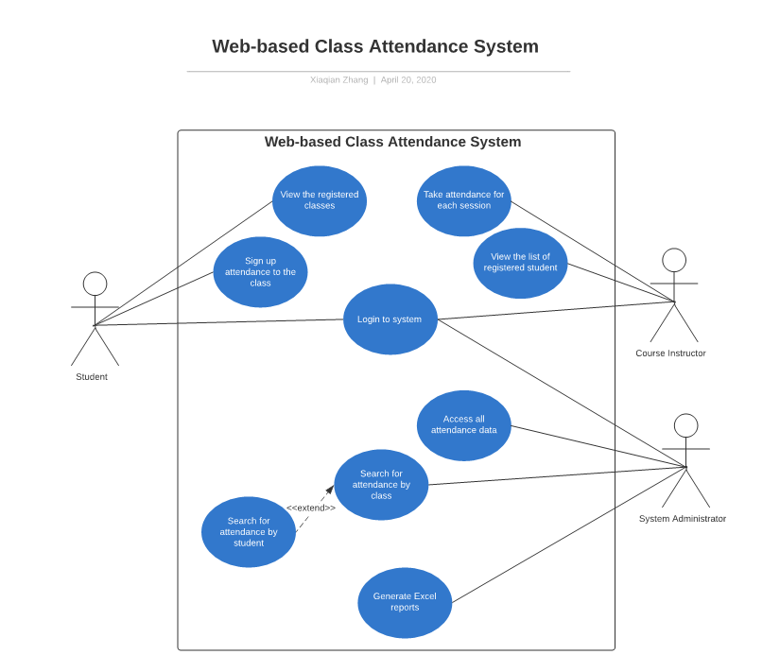Usage Model

Business Process Model
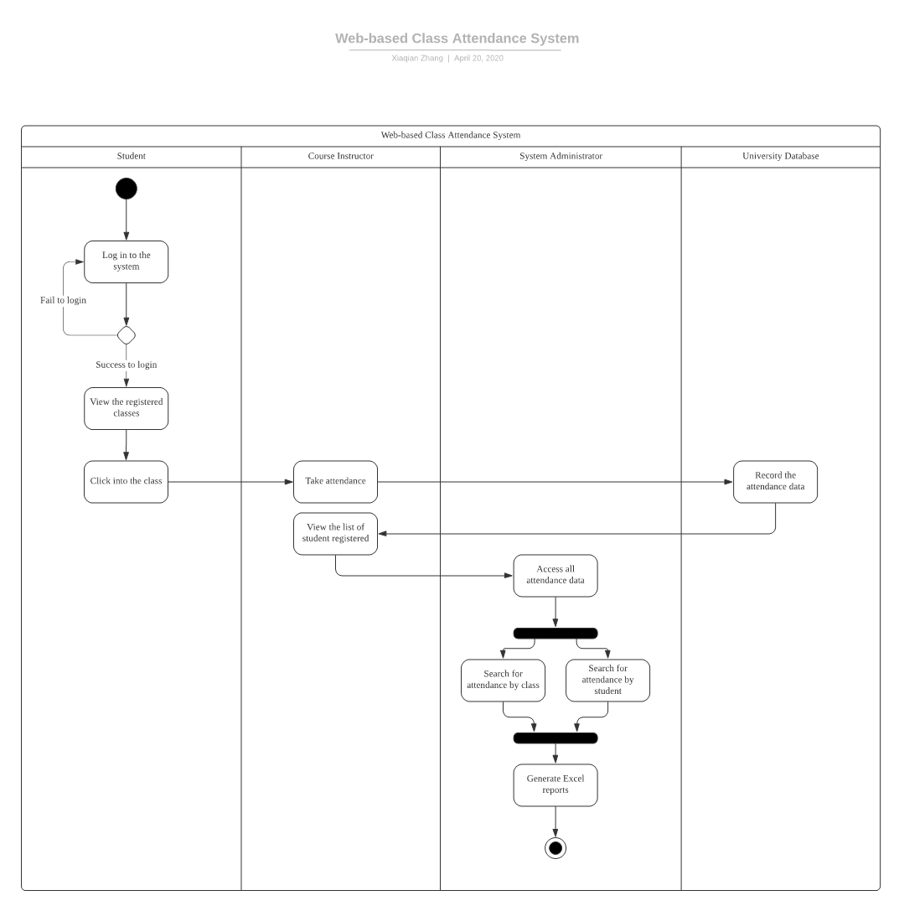

Conceptual Model

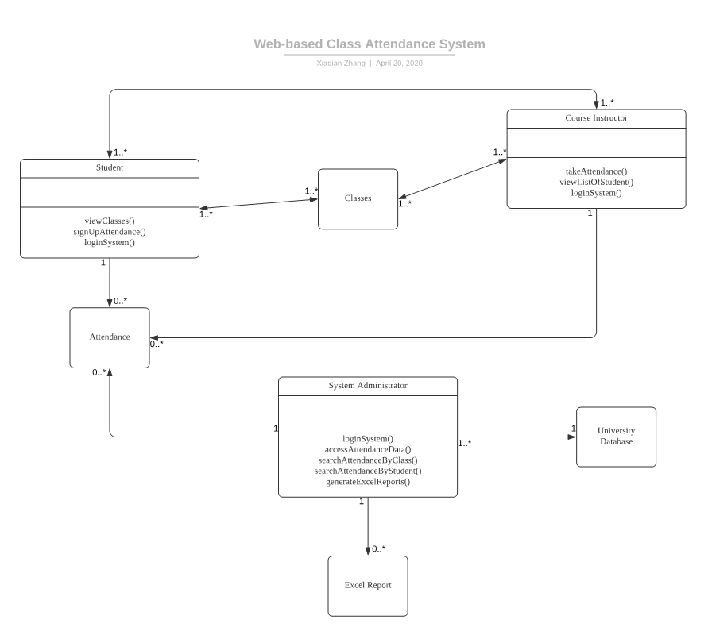

Test Scenario

Use Case: “Login to the system”
Scenario: “Student, instructor and system administrator are all able to login via their web-based class attendance system”
Test Cases:
1. Verify user to login with valid user account
2. Verify user are not able to login with invalid user account
3. Verify user are not able to login with system issues
4. Verify user are not able to login with network issues
Use Case: “View the registered classes”
Scenario: “Nancy view all her registered classes after she login to the attendance system”
Test Cases:
1. Verify user to view all registered classes with valid user account
2. Verify user are not able to view registered class with invalid user account
3. Verify user are not able to view registered class with system issues
4. Verify user are not able to view registered class with network issues
Use Case: “Sign up attendance to the class”
Scenario: “Nancy sign up her attendance to the required classes”
Test Cases:
1. Verify user to sign up the attendance with required and valid class
2. Verify user are not able to sign up the attendance due to instructor not open the access
3. Verify user are not able to sign up the attendance with system issues
4. Verify user are not able to sign up the attendance with network issues
Use Case: “Take attendance for each session”
Scenario: “Professor Brown take attendance for all of his student”
Test Cases:
1. Verify user to take the attendance with valid class access
2. Verify user are not able to take the attendance with invalid class access
3. Verify user are not able to take the attendance with system issues
4. Verify user are not able to take the attendance with network issues
Use Case: “View the list of registered students”
Scenario: “Professor Brown view the list of all registered students”
Test Cases:
1. Verify user to view the list of registered students with valid class access
2. Verify user are not able to view the list of registered students with invalid class access
3. Verify user are not able to view the list of registered students with system issues
4. Verify user are not able to view the list of registered students with network issues
Use Case: “Access all attendance data”
Scenario: “May access to all attendance data”
Test Cases:
1. Verify user access to all attendance data with valid login account
2. Verify user are not able to access to all attendance data with invalid login account
3. Verify user are not able to access to all attendance data with system issues
4. Verify user are not able to access to all attendance data with network issues
5. Verify user are not able to access to all attendance data with database crash
Use Case: “Search for specific attendance by class filter”
Scenario: “May search for CIS4800 DMWA’s attendance by class filter”
Test Cases:
1. Verify user can search for CIS4800 DMWA’s attendance with correct class filter
2. Verify user cannot search for CIS4800 DMWA’s attendance with incorrect class filter
3. Verify user cannot search for CIS4800 DMWA’s attendance with database crash
4. Verify user cannot search for CIS4800 DMWA’s attendance with typo
5. Verify user cannot search for CIS4800 DMWA’s attendance with system issues
6. Verify user cannot search for CIS4800 DMWA’s attendance with network issues
Use Case: “Search for specific attendance by student filter”
Scenario: “May search for Nancy’s attendance by student filter”
Test Cases:
1. Verify user can search for Nancy’s attendance with correct student filter
2. Verify user cannot search for Nancy’s attendance with incorrect student filter
3. Verify user cannot search for Nancy’s attendance with database crash
4. Verify user cannot search for Nancy’s attendance with typo
5. Verify user cannot search for Nancy’s attendance with system issues
6. Verify user cannot search for Nancy’s attendance with network issues
Use Case: “Generate Excel reports”
Scenario: “May transit the attendance data and generate excel reports”
Test Cases:
1. Verify user can generate excel reports with valid account
2. Verify user cannot generate excel reports within valid account
3. Verify user cannot generate excel reports with database crash
4. Verify user cannot generate excel reports with system issues
5. Verify user cannot generate excel reports with network issues

Peer Review

Team Member | Tasks Completed | Total number of Tasks | Total Hours Working | Comments/Notes | Date tasks completed | Peer review notes | Review’s name
Rudy | Part 6/Helped with Peer review | 2 | 5 | · Helped organize Team/ Great job | 4/25 | · None | · Ronnie
Nasiha | Part 4 | 1 | 4 | · None | 4/25 | · None | · Ronnie
Xiaoqian Zhang | Part 5 | 1 | 5 | · None | 4/25 | · None | · Ronnie
Abdul | Part 3 | 1 | 4 | · Speedy Work | 4/20 | · None | · Ronnie
Ronnie | Organized team/ Assigned Roles/Part1/2/3 | 4 | 4 | Team Lead | 4/25 | None | Rudy
Total: |  | 9 | 22

# | Statement | Yes | No
1. | We finished all our tasks on time | X
2. | We collaborated and cooperated with each other | X
3. | Everyone contributed at least one idea to the deliverable | X
4. | Each decision was made as a group | X
5. | We communicated frequently and met at least twice per week until the deliverable was complete | X
6. | What did the team did best?  The best thing the team accomplished was our use of communication. We were in constant communication and made  Decisions as a team.
7. | What does the team need to improve for the next deliverable? We should set better deadlines for ourselves. We finished  In the nick of time, and a little more time would be useful.

Integrity Statements
Statement 1: Team Omega made sure to take proper care to cite information
Statement 2: Team Omega made sure to faithfully review our own work.

Ronnie Procida
Rudy Bi | RB
Abdul Wahab | 
XiaQian Zhang | XiaQian Zhang
Nasiha Jerin | Nasiha Jerin

